Grade 1/2 Curriculum Overview Term 1

The start of the year for 2019 has been a very good one. It was great to meet so many parents at the Meet and Greet night. We would love you to come and help in the classroom so if you would like to please see your child’s teacher

Inquiry into Reading
In Term 1, Grade 1/2 students have been learning comprehension strategies. These include; visualisation, prediction, making connections and summarising the text by sharing their knowledge. Students have been busy setting individual reading goals in Literacy and enjoying independent reading time from our class library. Students have also been using Digital Technologies, such as, Reading Eggs on the iPads to support their learning at school and at home. Please remember how important it is to read and discuss your home reader every day.

Inquiry into Writing
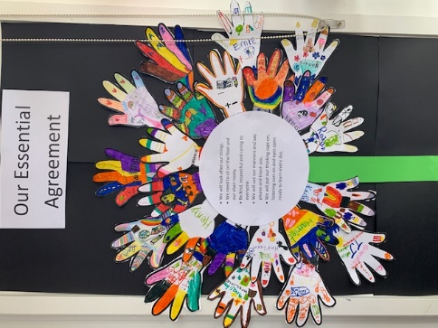
In Writing, we have been looking at various text types. These include; procedural, narrative and Writer’s Workshop (where students can write about whatever they choose). Students have personal writing goals that include spelling, text structure, handwriting and using different punctuation types. On Monday we explore a new sound for spelling which we explore through a list of words and practise throughout the week. Students are also learning how to form all letters neatly and correctly and write between the dotted third lines.

Speaking & Listening
Students have the opportunity to share their knowledge and communicate their ideas with their peers. Students are encouraged to show Learner Profile attributes and attitudes, such as, communicators, inquirers and being open-minded whilst working cooperatively in groups.

inquiry into Numeracy
In Numeracy, we have been exploring number – looking at the place value of numbers such as how many hundreds, tens and ones a number is made from. We have also been learning to read and write numbers in different ways including with numerals, words, tallies and resources such as bundles of icy pole sticks. We will also be ordering numbers and identifying the number that comes before and after. It is important that students begin to learn times tables

Home learning
Students are given home learning weekly. It is given out on a Monday and is expected to be returned on a Friday. Home learning consists of a numeracy, reading, writing and inquiry task. All home learning is a continuation of what students are inquiring into at school. Students are expected to complete 15 minutes of reading at home each night – reading and discussing your reader. G.W.P.S. also offers Mathletics and Reading Eggs to all students which is also completed weekly at home on a computer or IPad.

Our Units of Inquiry for Term One
Central idea  Our actions affect ourselves and others  Key Concepts  Form  Connection  Responsibility  Related Concepts  Safety, Relationships, Choice  Lines of Inquiry  - Different ways to be safe: traffic / road / bike/ cyber / water… (Responsibility)  - Our actions affect others (Causation)  - Everyone’s responsibility to be safe (Responsibility) | Central idea  Artefacts help us understand the past  Key concepts  Form  Change  Perspective  Related concepts  Past, present, future  Lines of Inquiry  - Artefacts have changed over time (Change)  - Artefacts have changed to improve our community (Form)  - Artefacts belong to a community (Connection)

