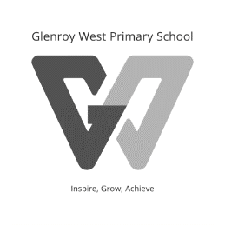

Glenroy West Primary School
York Street
P.O. Box 547
GLENROY 3046
Phone: 9306 8955
Fax: 9300 1028

2021
FOUNDATION
Book/Stationery Pack

Item | Quantity
My Alphabet Scrapbook | 1
READ IT Home Reading Diary Yellow Junior Level, 6th Edition 72 page version | 1
Packets Colouring Pencils Jumbo | 4
64 page Scrap Books | 4
A4 Handy Pouch Mesh | 1
A3 Handy Pouch Mesh (Independent Reading) | 1
Protext A4 Ex Book 18mm Dotted Thirds 96pp | 2
A4 24mm Dotted Thirds 48 Page Exercise Book  (Writing 1, Spelling 1) | 2
A4 Display Book, Refillable with Insert Front Cover | 1
Art Folio A2 (Art) | 1
24mm dotted third project book (Homework-2, Reading- 2, Writing- 1, Inquiry- 1, Indonesian- 1, Science-1) | 8
Glue Sticks 36 gm | 5
Scissors | 1
Tissues 20ply 100s | 2
Markers Pk 12 | 2
Jumbo Triangular 2B Pencil | 8
Eraser | 2
Sharpener – Micador – double Barrel with canister | 1
Whiteboard Marker - black | 1

